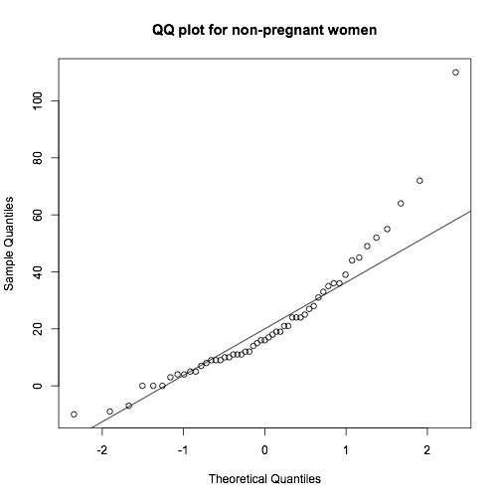
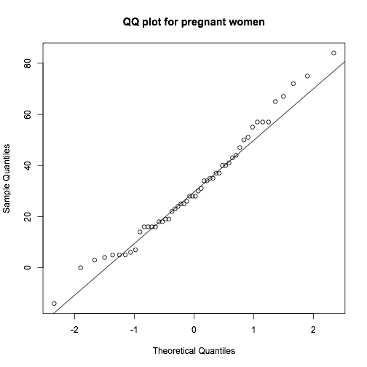

> summary(A)
Min. 1st Qu. Median Mean 3rd Qu. Max.
-10.00 9.00 16.00 21.57 31.00 110.00
> summary(B)
Min. 1st Qu. Median Mean 3rd Qu. Max.
-14.00 16.00 28.00 31.15 43.25 84.00
>
> A_length = length(A) # 53
> B_length = length(B) # 52

> ## Test statistic:
> ## Two-sided alternative:
> V1 = var(A)/var(B) # >1, df = (52, 51)
> V1
[1] 1.052923

> ## P-value:
> 2*pf(V1,52,51,lower.tail=FALSE)
[1] 0.8546354

> var.test(A, B, conf.level = 0.995, alternative="two.sided")

F test to compare two variances

data: A and B
F = 1.0529, num df = 52, denom df = 51, p-value = 0.8546
alternative hypothesis: true ratio of variances is not equal to 1
99.5 percent confidence interval:
0.4742784 2.3315850
sample estimates:
ratio of variances
1.052923

Since p-value is 0.8 which is much larger than the significance level 0.01, we can conclude that we fail to reject null hypothesis, H0 :σ12 =σ2

There is no significance evidence that the true variance in glucose tolerance test results for non-pregnant women differs from the true variance in glucose tolerance test results for pregnant women.

b)

> abar=mean(A)
> abar
[1] 21.56604
> bbar=mean(B)
> bbar
[1] 31.15385

> # Sample sizes:
> m=length(A) # 53
> n=length(B) # 52
>
> # Pooled sample variance:
> s2.pool = ((m-1)*var(A) + (n-1)*var(B))/(m+n-2)
>
> ## Test statistic:
> U = (abar-bbar)/sqrt(s2.pool*(1/n+1/m))
> U
[1] -2.279946

> ## P-value:
> pt(U,m+n-2) # 0.01231833
[1] 0.01233588
>
> ## confidence interval
quant = qt(0.995, n+m-2)
(abar-bbar) + c(-1,1)*quant*sqrt((1/n+1/m)*s2.pool)

> t.test(A, B, conf.level = 0.995, var.equal=TRUE, alternative = "less")

Two Sample t-test

data: A and B
t = -2.2799, df = 103, p-value = 0.01234
alternative hypothesis: true difference in means is less than 0
99.5 percent confidence interval:
-Inf 1.448555
sample estimates:
mean of x mean of y
21.56604 31.15385

Since p-value is 0.012 which is somewhat larger than the significance level 0.01, we can conclude that we fail to reject null hypothesis, H0 :μ1 =μ2

There is no significance evidence that the true mean glucose tolerance test results for non-pregnant women is less than the true mean glucose tolerance test results for pregnant women.

> qbeta(0.975, 19, 8) # 0.856
[1] 0.85674
> qbeta(0.025, 19, 8) # 0.522
[1] 0.5221252
>
> binom.test(18, 25, conf.level = 0.95, alternative = "two.sided") $ conf.int[1:2]
[1] 0.5061232 0.8792833
> # 0.5061232 0.8792833

